THE APOLLO UNIVERSITY

Application Form for the Recognition of PhD Supervisors/Co-Supervisors
(Please type information; hand-written applications will not be considered)

PERSONAL DATA

Name (in block letters): Dr. Praveen Hoogar
1 | 3
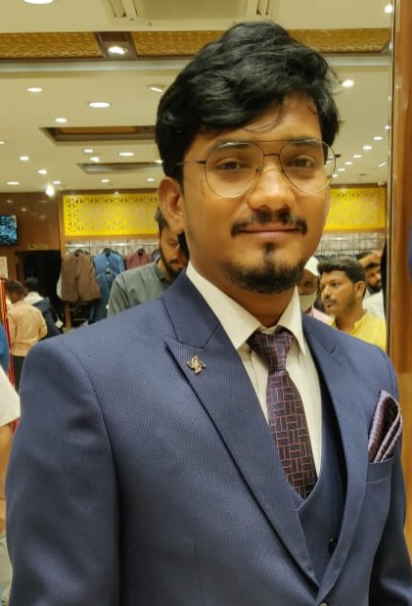
0 | 5
Date of Birth:
1 | 9 | 8 | 9
(dd/mm/yyyy)

Designation: Assistant Professor

Employee ID (For Chittoor campus): 01749

Scopus ID: 57204240256
ORCID: 0000-0003-2170-5643
Department: Institution/centre name: School of Social Sciences
Gender: Male Female

Permanent Address: At: Devarakonda, Post: Mukkal
Tq: Kalaghatagi, Dist: Dharwad
Pin
5 | 8 | 1 | 2 | 0 | 4

Address for Correspondence: Assistant Professor, School of Social Sciences
3rd Floor, The Apollo University, Chittoor
(OFFICIAL)
Pin
5 | 1 | 7 | 1 | 2 | 7

Phone: STD Code Number
Mobile: 9632279631

E-mail/s: praveen_h@apollouniversity.edu.in praveenhoogar@gmail.com

ACADEMIC RECORD (Enclose attested copies)

Year | Course | College/ University | AGG.  Marks
2019 | Ph.D | Karnatak University, Dharwad | Awarded
2014 | UGC-NET | University Grant Commission | Qualified
2010-2012 | Masters in Anthropology | Karnatak University, Dharwad | 78.25%
2007-2010 | Bachelor of Arts (optional Kannada, History, Socialogy) | Good News Welfare Society’s Arts and Commerce First Grade College, Kalghatagi. | 71%

TEACHING RECORD

Sl.No | Designation | Organization | During
1. | Assistant Professor and  Coordinator | Centre for Bio Cultural Studies, MAHE,  Manipal | 2019-2023
2. | Teaching Assistant/ Guest  Lectures | Department of Anthropology,  Karnatak University, Dharwad | 2018-2019

RESEARCH RECORD

Designation | Department/Lab | Institution | Period
1. | Research Associate | Transdisciplinary Centre for Qualitative  Methods, MAHE, Manipal | 2017-2018
2. | Research Assistant/ Field Investigator | Karnataka State Tribal Research Institute, Mysore Government of Karnataka | 2012-2013

RESEARCH PUBLICATIONS

International Journals | National Journals | International Conferences | National Conferences | Reviews | Books
40 |  | 10 | 6 | 5 | 4

DETAILS OF 5 SCOPUS/WoS INDEXED ORIGINAL RESEARCH ARTICLE PUBLICATIONS AS FIRST/CORRESPONDING AUTHOR

(review articles/meta-analysis/ letter to editor/co-authored articles etc. will not be considered)

Sl No | Title of the Article | Name of the Journal | Indicate Journal indexed in Scopus/WoS | Month and Year of publishing | Indicate  First Author/  Corresponding author | Link to article if not yet reflected in Scopus | Link to your Scopus profile
1 | Attached at the end |  |  |  |  |  | https://www.scopus.com/authid/detail.uri?authorId=57204240256
2
3
4
5

RESEARCH PROJECTS UNDERTAKEN / GRANTS SANCTIONED AS PI

(in last 5 years, enclose proof)

Sl. No. | Name of the Funding Agency | Title | Period | Amount
1. | ICSSR | The Siddi Tribe of Karnataka and their Changing Culture: an Ethnography | 3 years | 800000

RESEARCH PROJECTS UNDERTAKEN / GRANTS SANCTIONED AS Co-PI

(in last 5 years, enclose proof)
Sl. No. | Name of the Funding Agency | Title | Period | Amount

NUMBER OF THESIS GUIDED/GUIDING (enclose a detailed list)
 | Guided | Guiding | University
P. G. | 1 |  | IGNOU, New Delhi
Ph. D.

BROAD FIELD OF ACTIVE RESEARCH/ SPECIALIZATION (Provide 3-6 key words only)

Medical Anthropology, Ethnography
Publica Health
Global Burden of Diseases
Evidence Creation, Policy
Mixed Methods Research
Qualitative Research

I, Dr. Praveen Hoogar hereby declare that the information I have furnished here are true to the best of my knowledge.

Place:
Date: Signature

RECOMMENDATION BY THE HEAD OF THE DEPARTMENT

I recommend and forward the application of Prof./Dr. Dr. Praveen Hoogar for the PhD guideship of The Apollo University, Chittoor. Our department does not have any objection to him/her guiding the PhD candidates.

Place:
Date:

__________________________________________

Name and Signature of the Head of the Department
(With seal)

Phone:

Email id:

______________________________________________________________________

